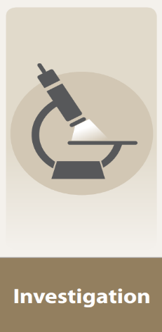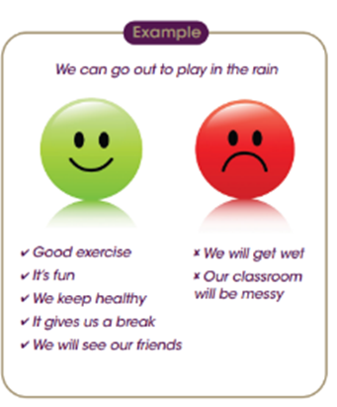

As a Scientist we will be showing resilience when I start finding something tricky and finding support to help me. I will be aspirational by explaining the new things I now know.

* Fair testing
* Observation
* I can compare different materials
* I can sort different materials depending on their properties.
* I can identify different objects from their material.
* I can test different materials suitability’s

We will be using the Good/Bad plan to decide what materials will be good to use in different situations. For example; a bridge, in the rain, a house.

Being a Scientist

Developing my Character

Developing as a learner

How do materials help us and our planet?