Knowledge Organiser – Science 2

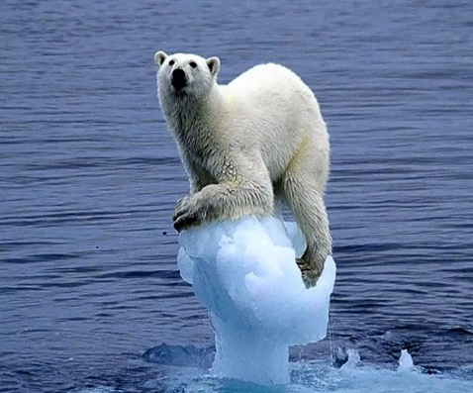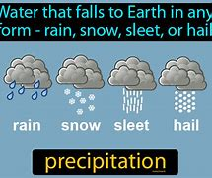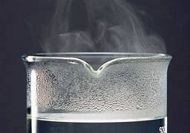

`

**Particles-** the smallest pieces of matter

**Accumulate** – to gather or join together

**Hypothesis** – a starting point for investigation. An idea of an explanation

**Condense** – to make something more concentrated or more dense

Key Vocabulary

**Precipitation-**rain, sleet, snow that falls to the ground

**Change of state-** a physical change in matter from gas, solid or liquid

**Evaporation-** process of turning from liquid to vapour

**Thermometer-** an instrument for measuring temperature

**Temperature-** a measure of hotness or coldness

**Celsius-** a scale of temperature

**Appearance –** how something looks

**Liquid –**something that flows, like water

**Gas-** matter of no fixed shape but can expand freely in containers

**Solid – firm in shape. Not liquid or fluid**

n

**Climate change** –changes in global climate patterns, resulting in increased levels of carbon dioxide

**Antarctic**- a continent in the Southern Hemisphere

**Water cycle** – the process of water circulating between the land, air and oceans of the Earth

