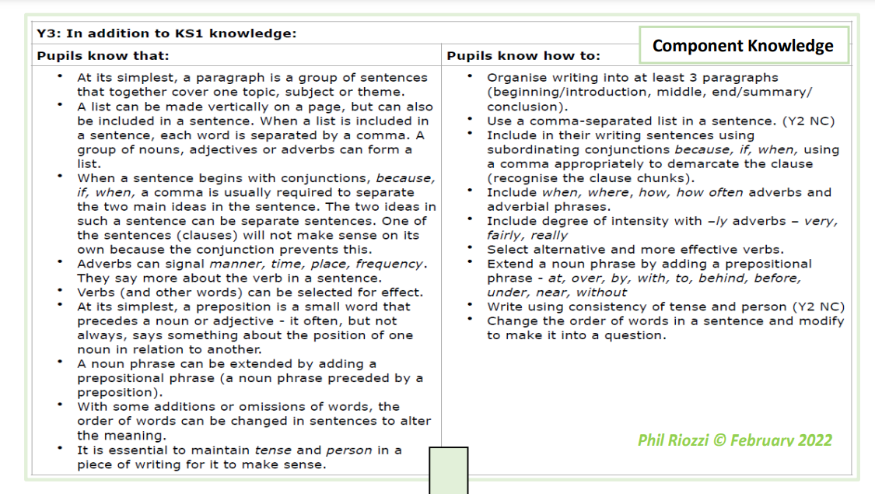
Year 3 Writing Expectations- including all KS1 expectations

Letter Formation
Children know how to:
- Increase the legibility, consistency and quality of handwriting, e.g.: by ensuring that down strokes of letters are parallel and equidistant;
- lines of writing are spaced sufficiently so that the ascenders and descenders of letters do not touch.
Planning, drafting and Editing
In addition to KS1 knowledge, children know how to:
- use ideas from their own reading and modelled examples to plan their writing.
- begin to proofread their own and others’ work to check for errors (with increasing accuracy) and to make improvements –purple editing pens used regularly to edit and improve
- organise their writing into more detailed paragraphs around a theme (e.g. beyond 3 paragraphs – beginning middle and end).
Audience, Purpose and Structure
In addition to KS1 knowledge, children know how to:
- demonstrate an
- increasing understanding of purpose and audience
- by discussing writing similar to that which they are planning to write in order to understand and learn from its structure, vocabulary and grammar.
- use the structure of a wider range of text types (including the use of simple layout devices in non-fiction).
- make deliberate, ambitious word choices to add detail.
- create settings, characters and plot in narratives.
- begin to use dialogue to convey a character.
Sentence Structure (Including punctuation and grammar)
- maintain the correct tense (including the present perfect tense) throughout a piece of writing with accurate subject/verb agreement.
- use ‘a’ or ‘an’ correctly throughout a piece of writing.
- use simple conjunctions confidently and accurately.
- use subordinate clauses, extending the range of sentences with more than one clause by using a wider range of conjunctions, including when, if, because, and although.
- use a range of conjunctions, adverbs and prepositions to show time, place and cause.
- use the full range of punctuation from previous year groups.
- Punctuate direct speech (using inverted commas)

Grammar Terminology
Recognise and use the terms:
- Preposition
- Prefix
- Clause
- Subordinate clause
- Direct speech
- Inverted commas (speech marks)
- Ellipsis
- Bullet point
Phonic & Whole word spelling
- To spell words with the / eɪ/ sound spelt ‘ei’, ‘eigh’, or ‘ey’ (e.g. vein, weigh, eight, neighbour, they, obey).
- To spell words with the /ɪ/ sound spelt ‘y’ in a position other than at the end of words (e.g. mystery, gym). To spell words with a /k/ sound spelt with ‘ch’ (e.g. scheme, chorus, chemist, echo, character).
- To spell words ending in the /g/ sound spelt ‘gue’ and the /k/ sound spelt ‘que’ (e.g. league, tongue, antique, unique).
- To spell words with a / sh/ sound spelt with ‘ch’ (e.g. chef, chalet, machine, brochure).
- To spell words with a short /u/ sound spelt with ‘ou’ (e.g. young, touch, double, trouble, country).
- To spell words ending with the /zher/ sound spelt with ‘sure’ (e.g. measure, treasure, pleasure, enclosure).
- To spell words ending with the /cher/ sound spelt with ‘ture’ (e.g. creature, furniture, picture, nature, adventure).
Common Exception words
- To spell many of the Y3 and Y4 statutory spelling words correctly.

Prefixes and Suffixes
- To spell most words with the prefixes dis-, mis-, bi-, re- and de- correctly (e.g. disobey, mistreat, bicycle, reapply, defuse).
- To spell most words with the suffix -ly with no change to the root word; root words that end in ‘le’,‘al’ or ‘ic’ and the exceptions to the rules.
- To spell words with added suffixes beginning with a vowel (-er/-ed/- ing) to words with more than one syllable (unstressed last syllable, e.g. limiting offering).
- To spell words with added suffixes beginning with a vowel (-er/-ed/- en/-ing) to words with more than one syllable (stressed last syllable, e.g. forgotten beginning).
Further Spelling Conventions
- To spell some more complex homophones and near-homophones, including here/hear, brake/break and mail/ male.
- To use the first two or three letters of a word to check its spelling in a dictionary
Contexts (purpose) for Writing
Writing to inform: Art Enquiry - Information text about the artist and his work, to demonstrate an increasing understanding of purpose and audience.
Writing to describe: History Enquiry- comparing the lives of people from the Stone Age to our life now
Writing to express and elicit feelings: Narrative Enquiry- a day in the life of Rosa Parks (diary entry)
Writing to explain: Science Enquiry- information sheet about rocks and fossils and the different kinds of rocks
Writing to remember, revise and organise thinking- Thinking tools with the aid of teacher: geography
Enquiry- link to prior learning about Dartmoor and our local area to contrast temperate rainforest regions of
The South West
Writing to inform: Science Enquiry- diagram of the water cycle, employing the use of simple layout devices in non-fiction.
Writing to entertain: Poetry Enquiry- write a poem in the style of Michael Rosen
Writing to persuade: History Enquiry- How was Boudicca a great leader?

