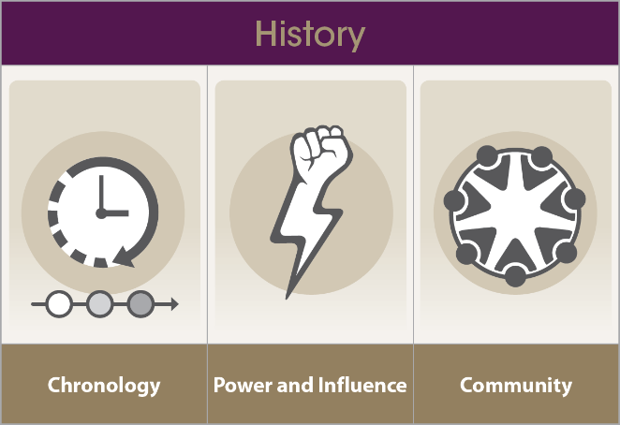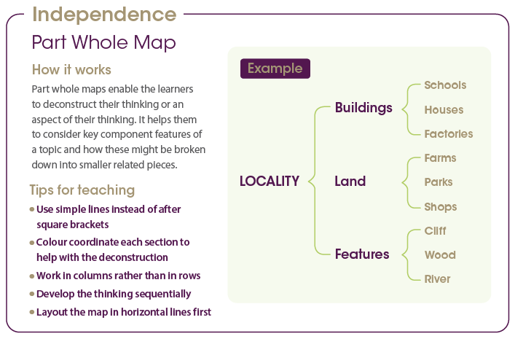

**Independence**

(Part whole model)

We will be introduced to the part whole map which is a new thinking tool. It will be used to explore ideas in a similar way to the bubble and double bubble maps that we have looked at before.

**Developing as a learner**

**Developing my character**

**Being a historian**

**Knowledge**

* Understand who Sir Francis Drake was.
* Understand what Sir Francis Drake did that was important to the history of the UK.
* Put events in order on a timeline.
* Understand how life was different in the past.

**Skills**

* Start to plan an enquiry and suggest where I might get reliable evidence from.
* Use a question to form the basis of something I would like to research.
* Use a range of sources to tell others about the past.

**Outcome:** To give a collaborative speech to persuade

**Was Sir Francis Drake a pirate?**

**Exploration**

