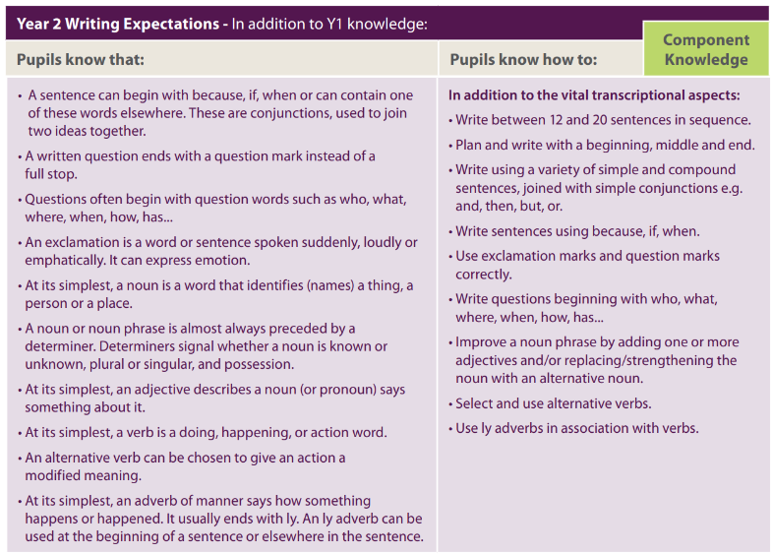

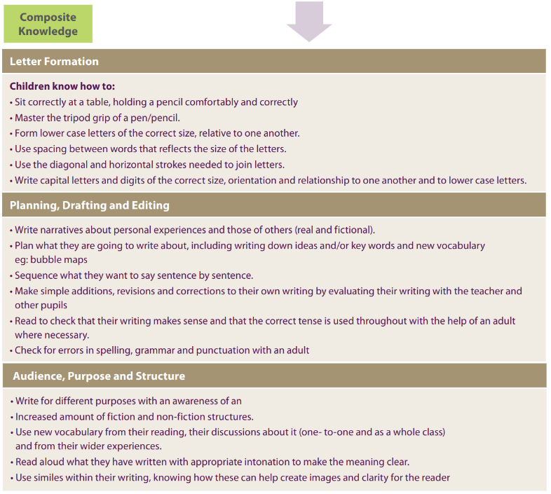

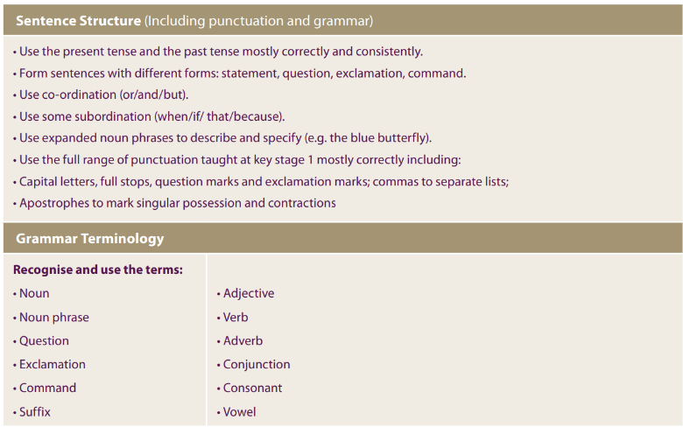

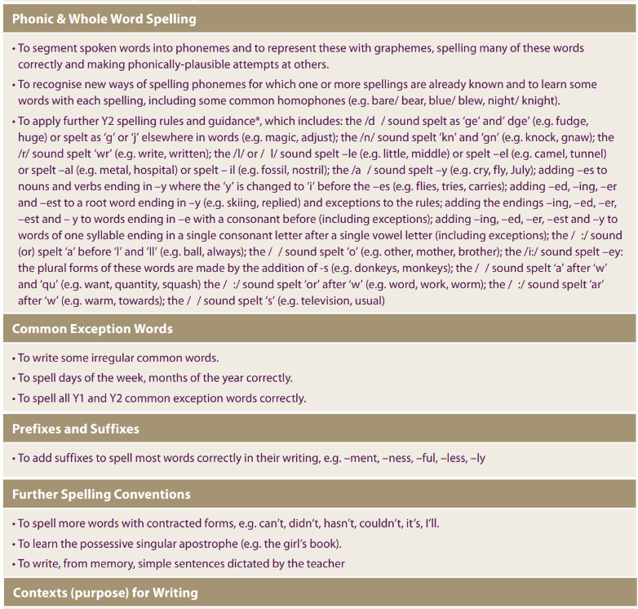

To include (not an exhaustive list): Biography writing linked to work on Rosa Parks (History), poetry inspired by Lewis Carroll, Narrative linked to Charlotte’s Webb.