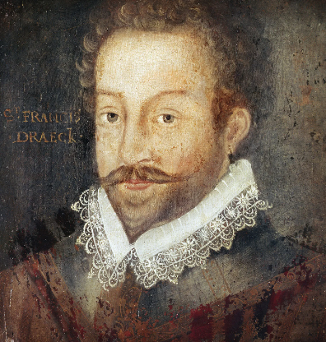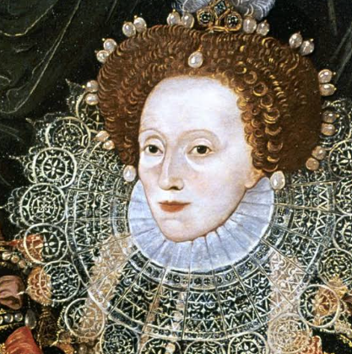

**Vocabulary**

Event

Century

Period

Consequence

Cause

Impact

Teamwork

Co-operation

Community

King

Queen

Empire

Pirate

Queen Elizabeth

Privateer

The Golden Hind

Sir Francis Drake

Plymouth

Spanish Armada

**Year 2**

**History: Sir Francis Drake**

Knowledge Organiser

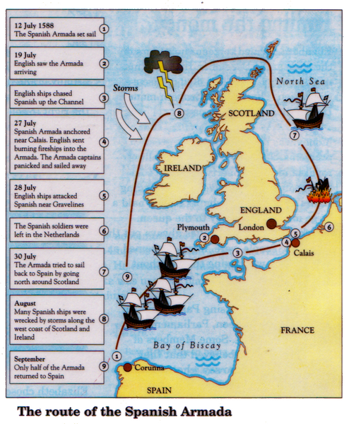

**Sir Francis Drake**

**Queen Elizabeth 1**

