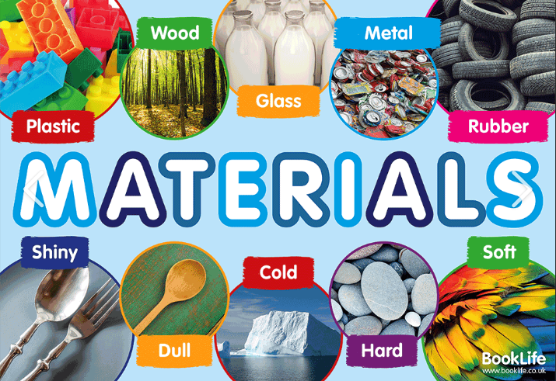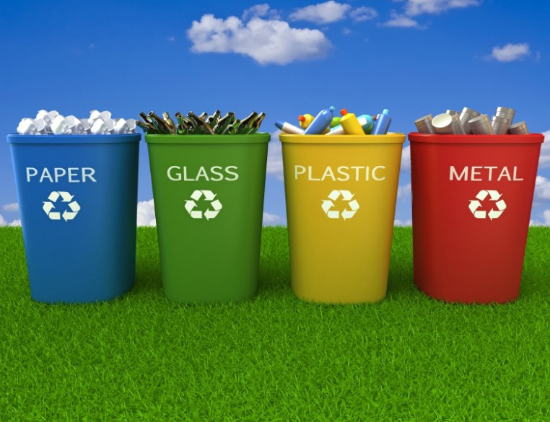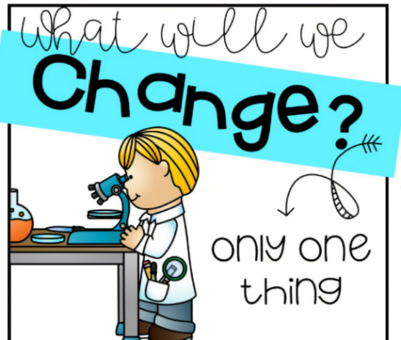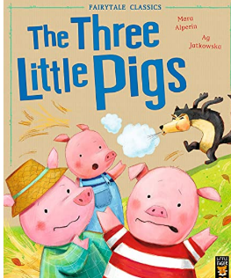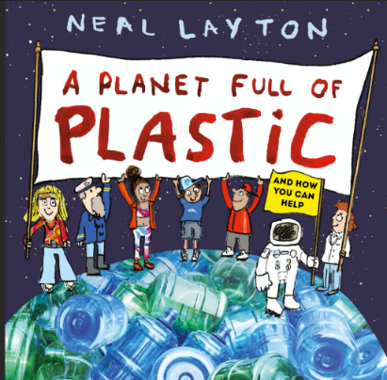

Materials and their properties

How do materials help us and our planet?

Why do we recycle?

Fair test

Vocabulary

* Materials
* Properties
* Waterproof
* Man-made
* Natural
* Observing
* Fair Test
* Wood
* Fabric
* Metal
* Glass
* Rock

Books