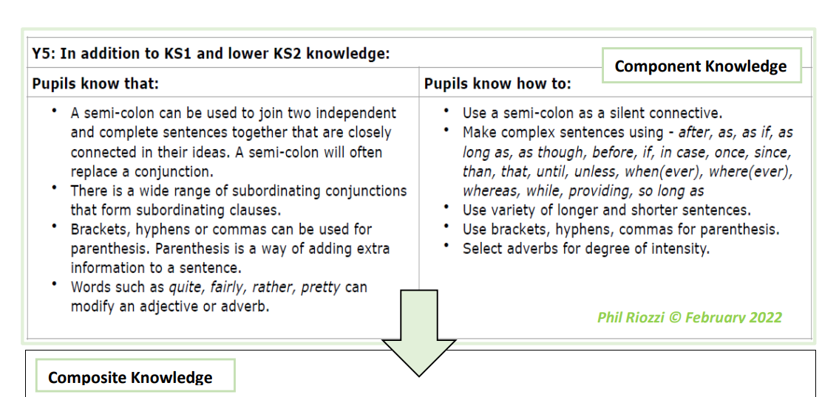

Year 5 Writing Expectations-including all KS1, Y3 and Y4 expectations
Letter Formation
. In addition to KS1 and lower KS2 knowledge, children know how to:
- confidently use diagonal and horizontal joining strokes when writing independently to increase fluency.
- begin to choose a standard of handwriting which is appropriate for a particular task, e.g. quick notes or a final handwritten version.
Planning, drafting and Editing
In addition to KS1 and lower KS2 knowledge, children know how to:

- plan their writing by identifying the audience for and purpose of the writing, selecting the appropriate form and using other similar writing as models for their own.
- consider, when planning narratives, how authors have developed characters and settings in what pupils have read, listened to or seen performed and use these as a basis for structuring their own writing.
- proofread work to précis (edit and shorten) longer passages by removing unnecessary repetition or irrelevant details.
- link ideas across paragraphs using cohesive devices.
- proofread their work to assess the effectiveness of their own and others’ writing, making corrections and improvements with purple pens

Audience, Purpose and Structure
In addition to KS1 and lower KS2 knowledge, children know how to:
- produce sustained and accurate writing from different narrative and non-fiction genres with
- appropriate structure, organisation and layout devices for a range of audiences and purposes.
- describe settings, characters and atmosphere with carefully- chosen vocabulary to enhance mood, clarify meaning and create pace.
- use dialogue to convey a character and to advance the action.
- perform their own compositions confidently using appropriate intonation, volume and movement so that meaning is clear.
- Use figurative language (including metaphors and personification) to add more detail and to improve description
Sentence Structure
- use a range of adverbs and modal verbs to indicate degrees of possibility, e.g. surely, perhaps, should, might, etc.
- ensure the consistent and correct use of tense throughout all pieces of writing.
- use a range of conjunctions accurately, varying the position within the sentence.
- use a wide range of linking words/phrases between sentences and paragraphs to
- build cohesion, including time adverbials (e.g. later), place adverbials (e.g. nearby) and number (e.g. secondly).
- use relative clauses beginning with a relative pronoun with confidence.
- to use the passive voice.
- Use commas consistently to clarify meaning and avoid ambiguity
- Use brackets, dashes or commas to indicate parenthesis
- Use a colon or semi colon in lists to separate clauses
Grammar Terminology
In addition to KS2 terminology, recognise and use the terms:
- Modal verb
- Relative pronoun
- Relative clause
- Parenthesis
- Brackets
- Dash
- Cohesion
- Commas for clarity
Phonic & Whole word spelling
- To spell words with endings that sound like / shuhs/ spelt with -cious (e.g. vicious, precious, conscious, delicious, malicious, suspicious).
- To spell words with endings that sound like / shuhs/ spelt with –tious or -ious (e.g. ambitious, cautious, fictitious, infectious, nutritious).
- To spell words with ‘silent’ letters (e.g. doubt, island, lamb, solemn, thistle, knight).
- To spell words containing the letter string ‘ough’ (e.g. ought, bought, thought, nought, brought, fought, rough, tough, enough, cough, though, although, dough, through,thorough, borough, bough, plough
Common Exception words
- To spell many of the Y5 and Y6 statutory spelling words correctly
Prefixes and Suffixes
- To convert nouns or adjectives into verbs using the suffix -ate (e.g. activate, motivate communicate).
- To convert nouns or adjectives into verbs using the suffix -ise (e.g. criticise, advertise, capitalise).
- To convert nouns or adjectives into verbs using the suffix -ify (e.g. signify, falsify, glorify). To convert nouns or adjectives into verbs using the suffix -en (e.g. blacken, brighten, flatten).
Further Spelling Conventions
- To spell complex homophones and near- homophones, including who’s/whose and stationary/stationery.
- To use the first three or four letters of a word to check spelling, meaning or both of these in a dictionary
Contexts (purpose) for Writing
- writing to describe – RE – describe the beliefs and practices of Islam
- writing to inform – Art Enquiry – writing and information leaflet for the exhibition
- Writing to express and elicit feelings- Narrative – Diary entry (Bessie Coleman
- Writing to remember, revise and organise thinking- thinking tools with the aid/support of teacher
- writing to entertain – Poetry Enquiry – Writing a poem in the style of Carol Ann Duffy
- writing to explain – Science – Explain forces/air resistance
- writing to persuade, giving a balanced argument and strongly justify own opinion and viewpoint – History – Relationship between Cortes and Montezuma
- writing to develop greater awareness and campaign - Geography – Persuasive speech on the effects of climate change on Guatemala

