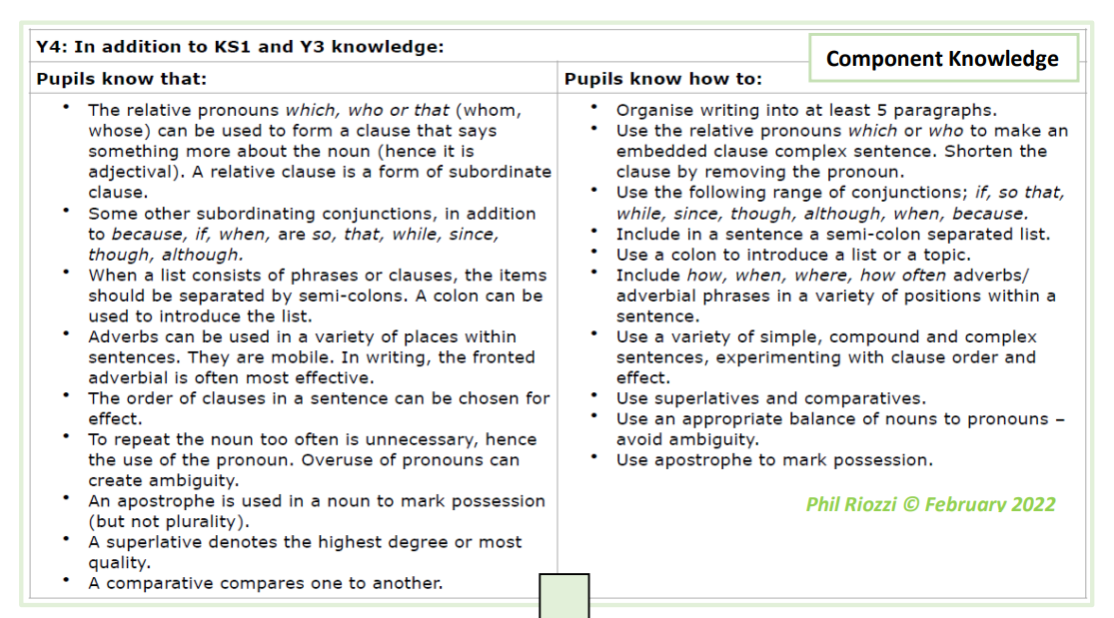
Year 4 Writing Expectations-including all KS1 and Y3 expectations

Letter Formation
In addition to KS1 and Year 3 knowledge, children know how to:
- Use the diagonal and horizontal strokes needed to join letters and understand which letters, when adjacent to one another, are best left not joined.
- Continue to Increase the legibility, consistency and quality of handwriting, eg: by ensuring that down strokes of letters are parallel and equidistant; that lines of writing are spaced sufficiently so that the ascenders and descenders of letters do not touch.
Planning, drafting and Editing
In addition to KS1 and Year 3 knowledge, children know how to:
- compose and rehearse sentences orally (including dialogue), progressively building a varied and rich vocabulary and an increasing range of sentence structures.
- consistently organise their writing into paragraphs around a theme to add cohesion and to aid the reader.
- proofread and amend their own and others’ writing, correcting errors in grammar, punctuation and spelling and adding nouns/ pronouns for cohesion using purple editing pens.
Audience, Purpose and Structure
In addition to KS1 and Year 3 knowledge, children know how to:
- write a range of narratives and nonfiction pieces using a consistent and
- appropriate structure (including genre specific layout devices eg: text boxes, bullet points etc)
- write a range of narratives that are well- structured and well-paced.
- create detailed settings, characters and plot in narratives to engage the reader and to add atmosphere.
- use dialogue to convey a character and to start to advance the action.
Sentence Structure (Including punctuation and grammar)
- maintain an accurate tense throughout a piece of writing.
- use Standard English verb inflections accurately, e.g. ‘we were’ rather than ‘we was’ and ‘I did’ rather than ‘I done’.
- use subordinate clauses, extending the range of sentences with more than one clause by using a wider range of conjunctions, which are sometimes in varied positions within sentences.
- Use expanded noun phrases with the addition of ambitious modifying adjectives and prepositional phrases, e.g. the heroic soldier with an unbreakable spirit.
- consistently choose nouns or pronouns appropriately to aid cohesion and avoid repetition.
- Use all the necessary punctuation in direct speech, including a comma after the reporting clause and all end punctuation within the inverted commas
- Consistently use apostrophes for the singular and plural possession
- To use a colon and semi colon for lists

Grammar Terminology
In addition to Y3 terminology recognise and use the terms:
- Determiner
- Pronoun
- Possessive pronoun
- Adverbial phrase
- Synonym
- Antonym
- Reporting clause
Phonic & Whole word spelling
- To spell words with / shuhn/ endings spelt with ‘sion’ (if the root word ends in ‘se’, ‘de’ or ‘d’, e.g. division, invasion, confusion, decision, collision, television).
- To spell words with a / shuhn/ sound spelt with ‘ssion’ (if the root word ends in ‘ss’ or ‘mit’, e.g. expression, discussion, confession, permission, admission).
- To spell words with a / shuhn/ sound spelt with ‘tion’ (if the root word ends in ‘te’ or ‘t’ or has no definite root, e.g. invention, injection, action, hesitation, completion).
- To spell words with a / shuhn/ sound spelt with ‘cian’ (if the root word ends in ‘c’ or ‘cs’, e.g. musician, electrician, magician, politician, mathematician)
- To spell words with the /s/ sound spelt with ‘sc’ (e.g. sound spelt with ‘sc’ (e.g. science, scene, discipline, fascinate, crescent).
Common Exception words
- To spell all of the Y3 and Y4 statutory spelling words correctly
Prefixes and Suffixes
- To correctly spell most words with the prefixes in-, il-, im-, ir-, sub-, super-, anti-, auto-, inter-, ex- and non- (e.g. incorrect, illegal, impossible, irrelevant, substandard, superhero, autograph, antisocial, intercity, exchange, nonsense). To form nouns with the suffix -ation (e.g. information, adoration, sensation, preparation, admiration).
- To spell words with the suffix -ous with no change to root words, no definitive root word, words ending in ‘y’, ‘our’ or ‘e’ and the exceptions to the rule (e.g. joyous, fabulous, mysterious, rigorous, famous, advantageous)
Further Spelling Conventions
- To spell words that use the possessive apostrophe with plural words, including irregular plurals (e.g. girls’, boys’, babies’, children’s, men’s, mice’s).
- To use their spelling knowledge to use a dictionary more efficiently
Contexts (purpose) for Writing

