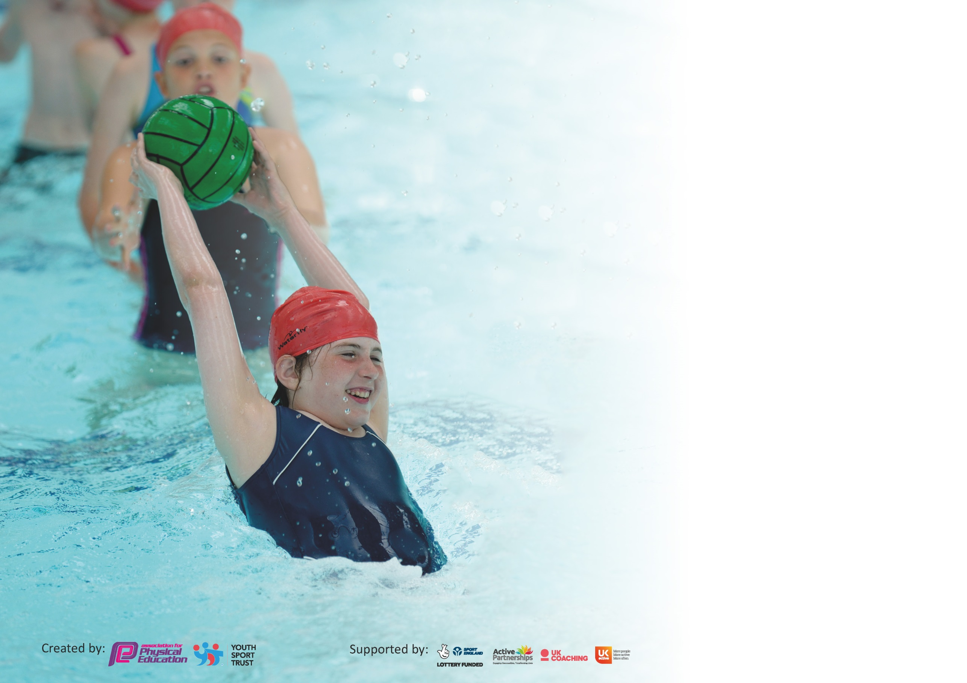

It is important that your grant is used effectively and based on school need. The Education Inspection Framework (Ofsted 2019 p64) makes clear there will be a focus on ‘whether leaders and those responsible for governors all understand their respective roles and perform these in a way that enhances the effectiveness of the school’.

Under the Quality of Education criteria (p41) inspectors consider the extent to which schools can articulate their curriculum (INTENT), construct their curriculum (IMPLEMENTATION) and demonstrate the outcomes which result (IMPACT).

To assist schools with common transferable language this template has been developed to utilise the same three headings which should make your plans easily transferable between working documents.

Schools must use the funding to make additional and sustainable improvements to the quality of Physical Education, School Sport and Physical Activity (PESSPA) they offer. This means that you should
use the Primary PE and Sport Premium to:

- Develop or add to the PESSPA activities that your school already offer
- Build capacity and capability within the school to ensure that improvements made now will benefit pupils joining the school in future years

Please visit gov.uk for the revised DfE guidance including the 5 key indicators across which schools should demonstrate an improvement. This document will help you to review your provision and to report your spend. DfE encourages schools to use this template as an effective way of meeting the reporting requirements of the Primary PE and Sport Premium.

We recommend you start by reflecting on the impact of current provision and reviewing the previous spend.

Schools are required to publish details of how they spend this funding as well as on the impact it has on pupils’ PE and sport participation and attainment by the end of the summer term or by 31st July 2022 at the latest.

We recommend regularly updating the table and publishing it on your website throughout the year. This evidences your ongoing self-evaluation of how you are using the funding to secure maximum, sustainable impact. Final copy must be posted on your website by the end of the academic year and no later than the 31st July 2022. To see an example of how to complete the table please click HERE.

Support for review and reflection - considering the 5 key indicators from DfE, what development needs are a priority for your setting and your pupils now and why? Use the space below to reflect on previous spend and key achievements and areas for development.

Key achievements to date until July 2021: | Areas for further improvement and baseline evidence of need:
Engaged more SEND & PP pupils in after school clubs and enrichment activities  Children more regularly active at lunchtimes  Improved understanding of fitness and health across the school  Developed range of high quality CPD for staff in autumn 2020 and spring 2021 | Address the increased need for children to be regularly active throughout the school day, owing to Covid-19.  Invest in enhanced package of support and training from Dartmoor Sports Partnership – enrichment activities and sports specialists working with teachers at Shaldon  Once Covid restrictions lifted in summer 21: Sports tournaments and swimming lessons to resume

Meeting national curriculum requirements for swimming and water safety. | To be completed in summer 2022
What percentage of your current Year 6 cohort swim competently, confidently and proficiently over a distance of at least 25 metres?
N.B. Even though your pupils may swim in another year please report on their attainment on leaving
primary school at the end of the summer term 2020.
What percentage of your current Year 6 cohort use a range of strokes effectively [for example, front crawl, backstroke and breaststroke]?
What percentage of your current Year 6 cohort perform safe self-rescue in different water-based situations?
Schools can choose to use the Primary PE and Sport Premium to provide additional provision for swimming but this must be for activity over and above the national curriculum requirements. Have you used it in this way?

Action Plan and Budget Tracking
Capture your intended annual spend against the 5 key indicators. Clarify the success criteria and evidence of impact that you intend to measure to evaluate for pupils today and for the future.

Academic Year: 2021/22 | Total fund allocated: £18,110 | Date Updated: September 2021
Key indicator 1: The engagement of all pupils in regular physical activity – Chief Medical Officer guidelines recommend that primary school pupils undertake at least 30 minutes of physical activity a day in school |  |  |  | Percentage of total allocation:
 |  |  |  | 75%
Intent | Implementation |  | Impact | £13,350
Children have opportunities for regular physical activity in school as part of their learning on Wellbeing | All YR1 – 6 pupils have 2 x 60 min PE lesson and access a broad and balanced curriculum. Monitored and training provided by specialist sports lead, B.Stevens.  Coaching from Trust Sports Lead, working closely with school Sports Lead in an online working group, also comprising other sports leads from trust schools  Daily Mile Circuit Set up. Sports Lead to set up regular lunch time running challenges, with specific guidance and support targeted at PP children | £13,350  (% Sports Specialist Cost – B.Stevens)  Trust-wide training, £100 admin/hourly costs | Pupils achieving expected and above  Good numbers at clubs and children highly active during morning and lunch breaks  Highly trained staff – clear progression and planning in developing skills in a wide range of activities.  Children running and walking regularly and for an extra 15 minutes daily on top of their current daily exercise. Daily Mile circuit used for termly competitions and high-profile charity events, such as the Great Ormond Street 5k Fun Run  Children able to be physically active during lunch breaks, exercise breaks throughout school day and at lunch times.
Key indicator 2: The profile of PESSPA being raised across the school as a tool for whole school improvement |  |  |  | Percentage of total allocation:
 |  |  |  | 25%
Intent | Implementation |  | Impact | £4,750
All pupils take part in a broad range of learning opportunities | Commitment to high quality PE by developing expertise amongst current staff – appointment and training of a sports lead to take over this academic year, following the retirement of our previous sports specialist  Accessing additional competitive and non-competitive opportunities through the SSP  All classes to attend at least one Festival per year  Children who attend clubs to be chosen to represent the school in SSP focus sport for that term – priority given to disadvantaged children  Additional sports equipment for SEND and PP children during external exercise breaks/Outdoor Climbing Trail | SSP £4,750 Sports Partnership Membership Cost  Included in Sports Partnership  £0 – Loan of equipment included in Sports Partnership | Children gain confidence in their abilities and recognise their strengths and weaknesses  Children motivated to challenge themselves  Children gain new skills and understanding, social skills, display our school values  Excellence in sports – motivation and engagement from children  Opportunities for all children to enjoy competitive sports  Learning more effective – children also more active at break times. Children more engaged and active during break times; learning more focussed owing to regular exercise breaks.

Key indicator 3: Increased confidence, knowledge and skills of all staff in teaching PE and sport |  |  |  | Percentage of total allocation:
 |  |  |  | %
Intent | Implementation |  | Impact | £1,275
Consistent high-quality learning across the school | Regular CPD opportunities through the SSP for PE coordinator and staff.  Premier Education providing lunch time clubs for PP children and those who are less active. 2 x 30 minute sessions every Wednesday.  High quality multi-sports clubs afterschool, subsidised for PP children, and additional CPD opportunities for staff across school to observe and take part.  Sports Lead working with Sports Partnership and MAT Sports Leads, developing the implementation of the ACE curriculum through modelling outstanding PE lessons.  CPD in PE scheduled throughout the year. | Included in £13,350 already budgeted in section 1  £42.50 per week  X 30 weeks:  £1,275  Included in £13,350 already budgeted in section 1 | High quality teaching in all aspects of the PE curriculum  Pupils achieving expected and above in PE. CPD schedule set up for the year  Progression in PE skills and knowledge developed in line with year group curriculum expectations. Staff on rota to  Confidence in developing their knowledge of the subject and how to use curriculum manuals to plan a sequence of skill progression for their year group  BS (Sports Lead) already planned in ‘Impact Days’ with visiting sports leads, who will come into school and model outstanding practice.  Trips to tournaments and events booked in throughout the year, exposing teaching staff across school to models of best practice.  Staff to complete personal development plans to track the impact of these events upon their own practice.
Key indicator 4: Broader experience of a range of sports and activities offered to all pupils |  |  |  | Percentage of total allocation:
 |  |  |  | %
Intent | Implementation |  | Impact | £1,500 (to be funded through roll-over funds from previous academic year)
Disadvantaged children have access to a wide range of outdoor education | Forest School training to develop well-being and broader opportunities for disadvantaged children.  Outdoor learning equipment | £1,100  £400 | D.Rees completed Forest School Leader training August 2021. Forest School sessions to be available for PP children from Sept 21. Broader training opportunities for staff across school, to increase number of PP children who can take part in Forest School sessions.  Disadvantaged children access outdoor education – greater confidence and resilience. Improved attendance for PP persistent absentees.

Key indicator 5: Increased participation in competitive sport |  |  |  | Percentage of total allocation:
 |  |  |  | %
Intent | Implementation |  | Impact | Included in £4,750 DSP fund and £13,350 investment in Sports Lead
Your school focus should be clear | Make sure your actions to | Funding | Evidence of impact: what do | Sustainability and suggested
what you want the pupils to know | achieve are linked to your | allocated: | pupils now know and what | next steps:
and be able to do and about | intentions: |  | can they now do? What has
what they need to learn and to |  |  | changed?
consolidate through practice:
More children gaining experience of the sport and developing character through competition. All children in the school will participate in at lest one competitive event per term.  More children achieving success at a higher level. Pupil surveys will track the increased motivation and desire to participate in competitive sport.  Y6 children being supported by Sports Lead to set up and run sports groups at lunchtimes. Higher % of PP children in Y6. Therefore this role will enable children to be come experts in specific sports, and therefore promote higher engagement in competitive sport. | Multi-skills sports event at Stover on 28th September  Impact days scheduled for November 2021  Sports Survey to be completed by October 10th, and repeated again at end of November, following impact day  D.Rees and B.Stevens have appointed Y6 ‘Sports Crew’ and activities will take effect w/c 27th Sept.  B.Stevens to oversee the running of Sports Crew and ensure that children’s knowledge and skills are continuously developed through this initiative. | As above | Greater resilience  Understanding of importance of healthy lifestyle and exercise to manage stress and anxiety during lockdown  Greater sense of well-being and achievement through sport, which has been a motivating factor in completing remote learning during the pandemic. | Continue to be fully engaged in the SSP  Continue to introduce new children to competition and nurture talent  Signpost children to community clubs

Signed off by
Head Teacher: | J.Stewart
Date: | 13th September 2021
Subject Leader: | Beth Stevens
Date: | 13th September 2021

